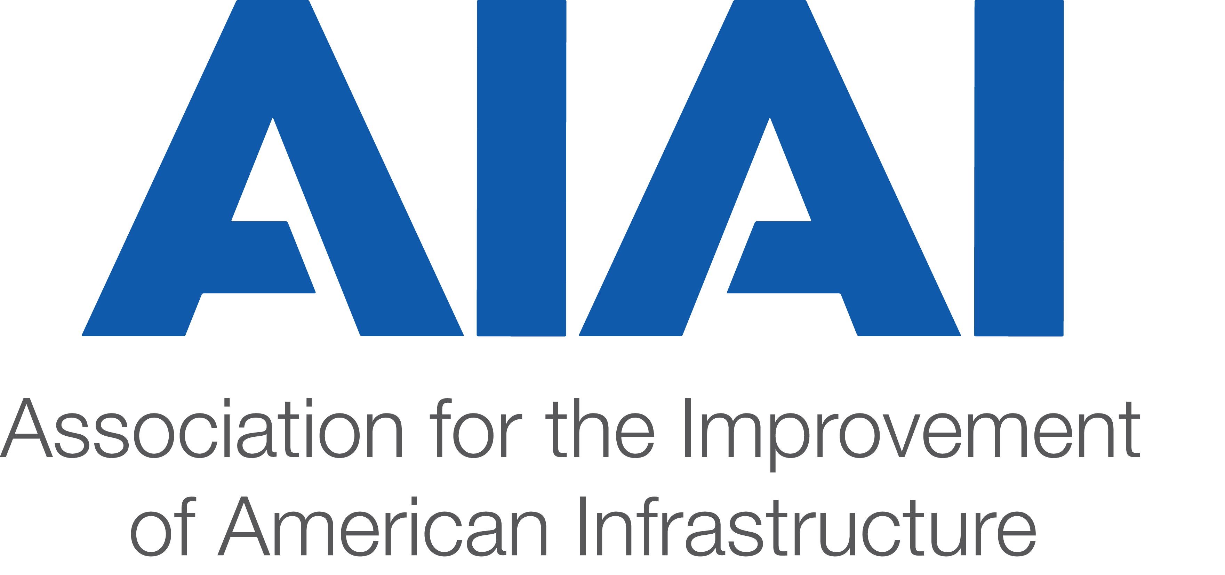
Water Committee
Draft
Minutes Thursday, August 3rd, 2017

Participants:
Steven Paquette,WSP, Committee Co-Chair
Sanford Stokes Kiewit Committee Co-Chair
Dex Brown,
Rich Distler, Granite Construction
Mark Ellison, IDE Technologies

Katherine Freeman, CNA
Marshall Macomber, Think P3
Brian Shell, WSP
John Parkinson, AIAI, Exec Dir (scribe)

ACTION ITEMS:
- Identify potential speakers|panelists for upcoming P3 Hub South : Due – Tues, Aug 8th
- Review WEFTEC opportunities and express interest in participating, as warranted
- Review working draft of P3 Questions | P3 Answers : Due – Friday Aug 18th
- Review WE&RF research initiative, and consider participation, as appropriate

WEFTEC:
Water Environment Federation Technical Exhibition & Conference is a 5 day event, to be held from Sept. 30th through Oct 4th, at McCormick Place in Chicago, Illinois. This industry products and processes, connects water professionals; enrichs the expertise of water professionals; and increases awareness of the impact and value of water in the environment & waste management sectors.
Specific panel information was shared (thank you Brian shell, WSP), and a copy attached to the minutes). Members are encouraged to consider participation or attendance, as their firm’s interests dictate. 25,000 + people attend each year.
Action Item: Review WEFTEC opportunities and connect directly with Brian Shell, WSP or Committee Co-Chairs regarding interest in parcitipating.

WE & RF:
Water Environment & Reuse Foundation (WE&RF) will initiate its research project. The focus will be on the governance of P3s in the water industry.
AIAI to be invited to participate, with individuals who may represent their firms and project work, as subject matter experts, or as resources for case studies (global and US).
Action Item: Review and consider WE&RF research initiative, as it aligns with interests of individual firms, or participation as a subject matter expert

WIFIA Update:
EPA announced the selection of 12 entities who are now able to apply for the first WIFIA loans. Those selected are seeking $2.3 billion in loans for $5.1 billion in water infrastructure projects. The entities selected to apply for WIFIA loans are:
- Miami-Dade County, Florida
- San Francisco Public Utilities Commission, California
- Metropolitan St. Louis Sewer District, Missouri
- City of Omaha, Nebraska
- Orange County Water District, California
- City of San Diego, California
- Indiana Finance Authority, Indiana (statewide)
- Seattle, King County, Washington
- Baltimore City Department of Public Works, Maryland
- Maine Water Company, Maine
- City of Morro Bay, California
- City of Oak Ridge, Tennessee

Action Item: Disseminate information regarding EPA selection for entities who may apply for inaugural round of WIFIA (attached to Minutes)
Educational Resources:
Draft of “P3 Questions | P3 Answers” was shared. Looking for member and expert input. Comments, suggections, actual answers (any of the above) requested by close of business Friday, August 18th. Updated edition will be turned around and shared with Water Committee members. Final deliverable review in time for the next Committee conference call (September 7th). Objective is to share with participants and attendees from the P3Q’s|P3A’s session at the P3 Water Summit.
Action Item: Review and comment on the working draft of P3 Questions | P3 Answers

Opportunities to participate in content delivery at industry conference. In addition to WEFTEC, there are other P3-specific conferences which may present opportunities to engage members in educational outreach. A near-term need is to identify public officials who could potentially contribute to discussions as part of the P3 Hub South (to be held in Miami, FLA, Oct 16-17)
Action Item: Identify potential speakers|panelists for upcoming P3 Hub South

Upcoming Events:
US Water Alliance Webinar, Sept. 6th, WSP’s Dave Sklar as a panelist
P3 Awards (P3 Bulletin), September 26th, Washington, DC – includes content during the day, leading to formal dinner, awards ceremony. Networking opportunities.
WEFTEC Sept 30th – Oct 4th, Chicago, IL – leading industry technical) conference, will include P3s and alternative project delivery methods among content.
Higher Education P3 Summit, Oct 2 – 3, San Diego, CA,
P3 Hub South, Oct 16 – 17, Miami, FLA, Water included in the agenda for discussion of market opportunities in the US southeastern region. Networking.
Federal P3 Conference, Nov 29 – 30, Washington, DC

Next Call: Thurs, September 7th, 2017. 4 PM (EDT).

From the US Water Alliance:
Upcoming September Webinar
Taking the Long View: Asset Management for Water Systems
September 6, 2017, 1pm-2pm ET

For many water utilities, a key part of managing system sustainability is thinking long-term and taking stock of how assets will hold up over time. With miles of pipes below ground and critical storage, treatment, and pumping assets above ground, getting a handle on the condition of these systems is often easier said than done. Learn how leading utilities and cities are using sophisticated asset management practices and a risk-based approach to help address the issues of evolving regulatory requirements, growing populations, demand for improved service and reliability - all while simultaneously addressing the challenges of water scarcity, a highly variable climate, aging infrastructure, and limited state and federal funding.
Speakers include:
Dave Sklar, Water and Utilities Asset Management Leader, WSP
Patrick Beane, Asset Manager, Johnson County Wastewater

Register

